- Provision for Maker & checker is required for Shortfall grade entry –
If completed, may I request you to submit the details of the T-codes?

- MCQ Qty. field is required in “YRVG052” T-code.
L4 testing observation:
- Customers with no rebate orders, or with zero discount value (in the case of group customers), should not be forwarded to L4. Only rebate orders generated against the discount values approved at L3 should be forwarded to L4 for further processing. :.
- Description in expense GL is still not recorded.
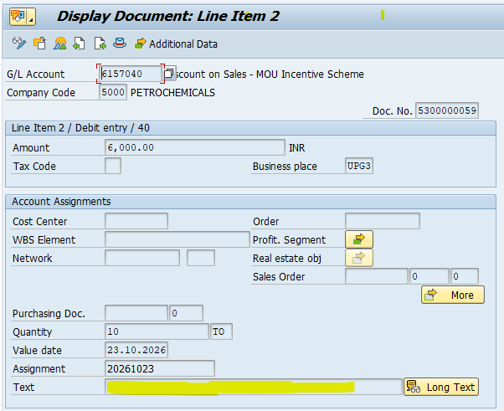

The Text field is manually updated after running t-code YRFR126. After which text is posted in expense GL. This process is currently followed by zonal F&A.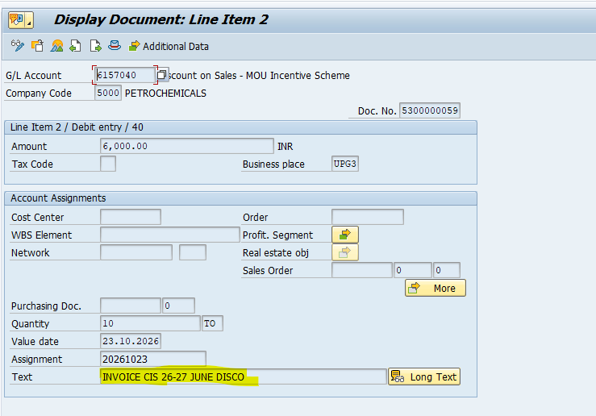

- The revised Note format largely fulfils our requirements. However, a few modifications are required in the auto-generated note:
1.L6 details are not required on Note (Sign, Time stamp, Comments & etc.)

2. Addition of Fixed Statements at Each Approval Level:
The following statements should be incorporated into the auto-generated note before the respective signatory details and timestamp at each level (L1 to L5):
- L1: Customer-wise and grade-wise sales quantities, along with eligible PSD rates and amounts, have been verified and confirmed after considering customer waivers, shortfall waivers, sales return quantities, and Group/MLE details.
- L2: Customer-wise eligible PSDs have been forwarded, and all supporting documents have been submitted to CPC.
- L3: Rebate orders have been created.
- L4: Customer-wise eligible PSDs have been vetted.
- L5: The discount proposal has been approved. CPC F&A is requested to process the discount disbursement to the respective customers.

Please find the Desired Note below:

GAIL (India) Limited

Petrochemical Marketing Group, Delhi
Approval Note # CIS 26-27 JUNE DISCO
Ref. No. GAIL/PMG/CPC/PSD Discount disbursement
Date 14.10.2026
Subject: Disbursement of Discounts for Monthly CIS (01.06.2026 to 30.06.2026 )
Background: PMG communicated discount variants for processing discounts for the above variant.
Main Body: The discounts have been processed through variants created by PMG. The discounts generated
through variants have been cross-checked with discount circulars sent by the PMG.
The summary of discounts is tabulated below for approval and onward transfer to customers by CPC F&A.
Discount total value (Rs.) 34,127,700.00
APPROVING AUTHORITY:
As per SOP for Centralized Processing of Post Sales Discounts S.No.4: "Discounts proposal is to be forwarded to
CPC Head-PC Mktg (not less than E7) for approval."
Submitted for approval please.
L1: Customer-wise, grade-wise sales quantities, along with eligible PSD rates and amounts, have been verified and confirmed after considering customer waivers, shortfall waivers, sales return quantities, and Group/MLE details.

L2: Customer-wise eligible PSD have been forwarded, and all supporting documents have been submitted to CPC.

S.No. | Sales Office | L1 |  |  | L2 |  |  | Discount Value (Rs.)
S.No. | Sales Office | Remarks | CPF No. | Time& Date Stamp | Remarks | CPF No. | Time& Date Stamp | Discount Value (Rs.)
1 | 2000 | FOR APPROVAL | 00016092 | 00016092  08.10.2026 17:41:20 | FOR APPROVAL | 00019479 | 00019479  08.10.2026 17:47:49 | 27,421,200.00
2 | 3000 | APPROVED | 00016092 | 00016092  05.10.2026 17:33:58 | APPROVED. | 00019479 | 00019479  06.10.2026 12:39:55 | 3,447,000.00
3 | 4100 | APPROVED | 00016092 | 00016092  08.10.2026 11:16:37 | APPROVED | 00019479 | 00019479  08.10.2026 11:20:12 | 3,259,500.00
Grand Total

L3: Rebate orders have been created.

Comments/Remarks (L3) MAY BE APPROVED

L3 digital signature, CPF No. & Time Stamp 00016161 08.10.2026 17:10:06

L4: Customer-wise eligible PSDs have been vetted.

Comments/Remarks (L4) CHECKED
L4 digital signature, CPF No. & Time Stamp 00016212 09.10.2026 17:47:01

L5: The Discount proposal has been approved. CPC F&A is requested to process the discount disbursement to the respective customers.
Comments/Remarks (L5) OK

L5 digital signature, CPF No. & Time Stamp 00016286 14.10.2026 12:30:35

